**Health Talents International**

**Surgical Trip Information Packet**

**(Date of Trip)**

Thanks for your interest in traveling to Guatemala to become a Health Talents surgical clinic team member! We welcome your participation and look forward to working with you. If you are trying to make a decision about going, you can find some helpful information on our website <http://healthtalents.org/missiontrips.php>. Feel free to call Sheri Kretzschmar if you have questions at (828-201-9739) or email at [fscubarn@aol.com](mailto:fscubarn@aol.com)

Here is information that you will need as you get ready to go!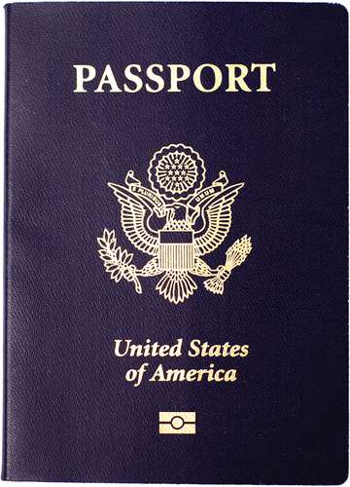

**PASSPORT**

You cannot travel to Guatemala without a current U.S. passport. We suggest you make 2 color copies of the “face” page, put one in your luggage and one in your carry on just in case. If you carry your smartphone, take a photo of the face page. Keep your passport safe, it is extremely valuable!

**TRIP AGENDA**

**SATURDAY:**  Arrive in Guatemala City. Travel by bus to Montellano where Clinica Ezell is located (about 3 hours). Unpack, settle in, and get to know your new friends.

**SUNDAY:**  Walk across the street to attend worship services at the Montellano Iglesia de Cristo. Set up for surgery, do pre-op exams, then begin operating.

**MONDAY - THURSDAY:**  Surgeries and all post-op work continues.

**FRIDAY:** Return to Guatemala City for your return flight or chose a tourist day! Bus will pick us up after breakfast for the 3-hour trip to the airport or 2-hour trip to Antigua for a day of sightseeing and shopping. Final dinner together at our hotel for those spending the day in Antigua (Porta Hotel Antigua).

**SATURDAY:** Have a nice buffet breakfast, (unless you are on the early flight home), shuttle to the airport around 9 am and fly home.

**FOOD & WATER**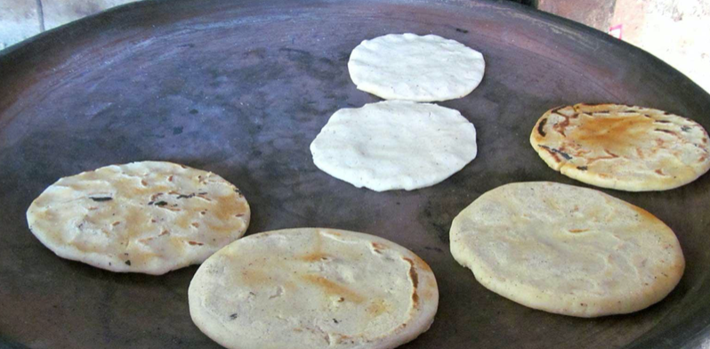

Purified water is available at several dispensers around Clinica Ezell . You will receive a reusable water bottle when you arrive. There is a refrigerator with soft drinks available and fresh squeezed juice is offered at meals.

Our cooks have been working hard to provide nutritious, safe meals for our teams for years. The food is a highlight of the trip. If you want to bring a few snacks for your room, feel free.

**MONEY**

Normally you will not need money until Friday before you return home. We will go to Antigua where you will be able to buy souvenirs. You will also be responsible for your lunch that day. Saturday you may want something at the airport. The easiest way to get money exchanged is by using your debit card at the ATM in the hotel lobby in Antigua.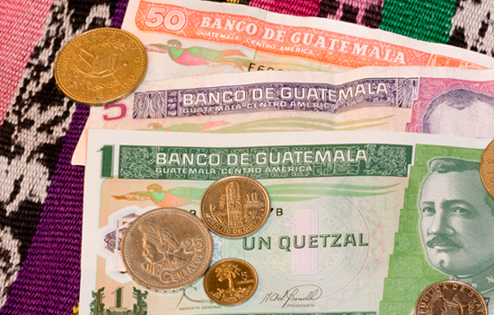

* Current exchange rate is 7.5:1 between the Guatemalan quetzal and the U.S. dollar.
* Stores and most street vendors take U.S. Dollars as long as they are not torn or wrinkled.
* Most stores and restaurants take credit and debit cards.
* Do not bring denominations higher than 20-dollar bills.

**WHAT TO PACK - WHAT TO WEAR**

* 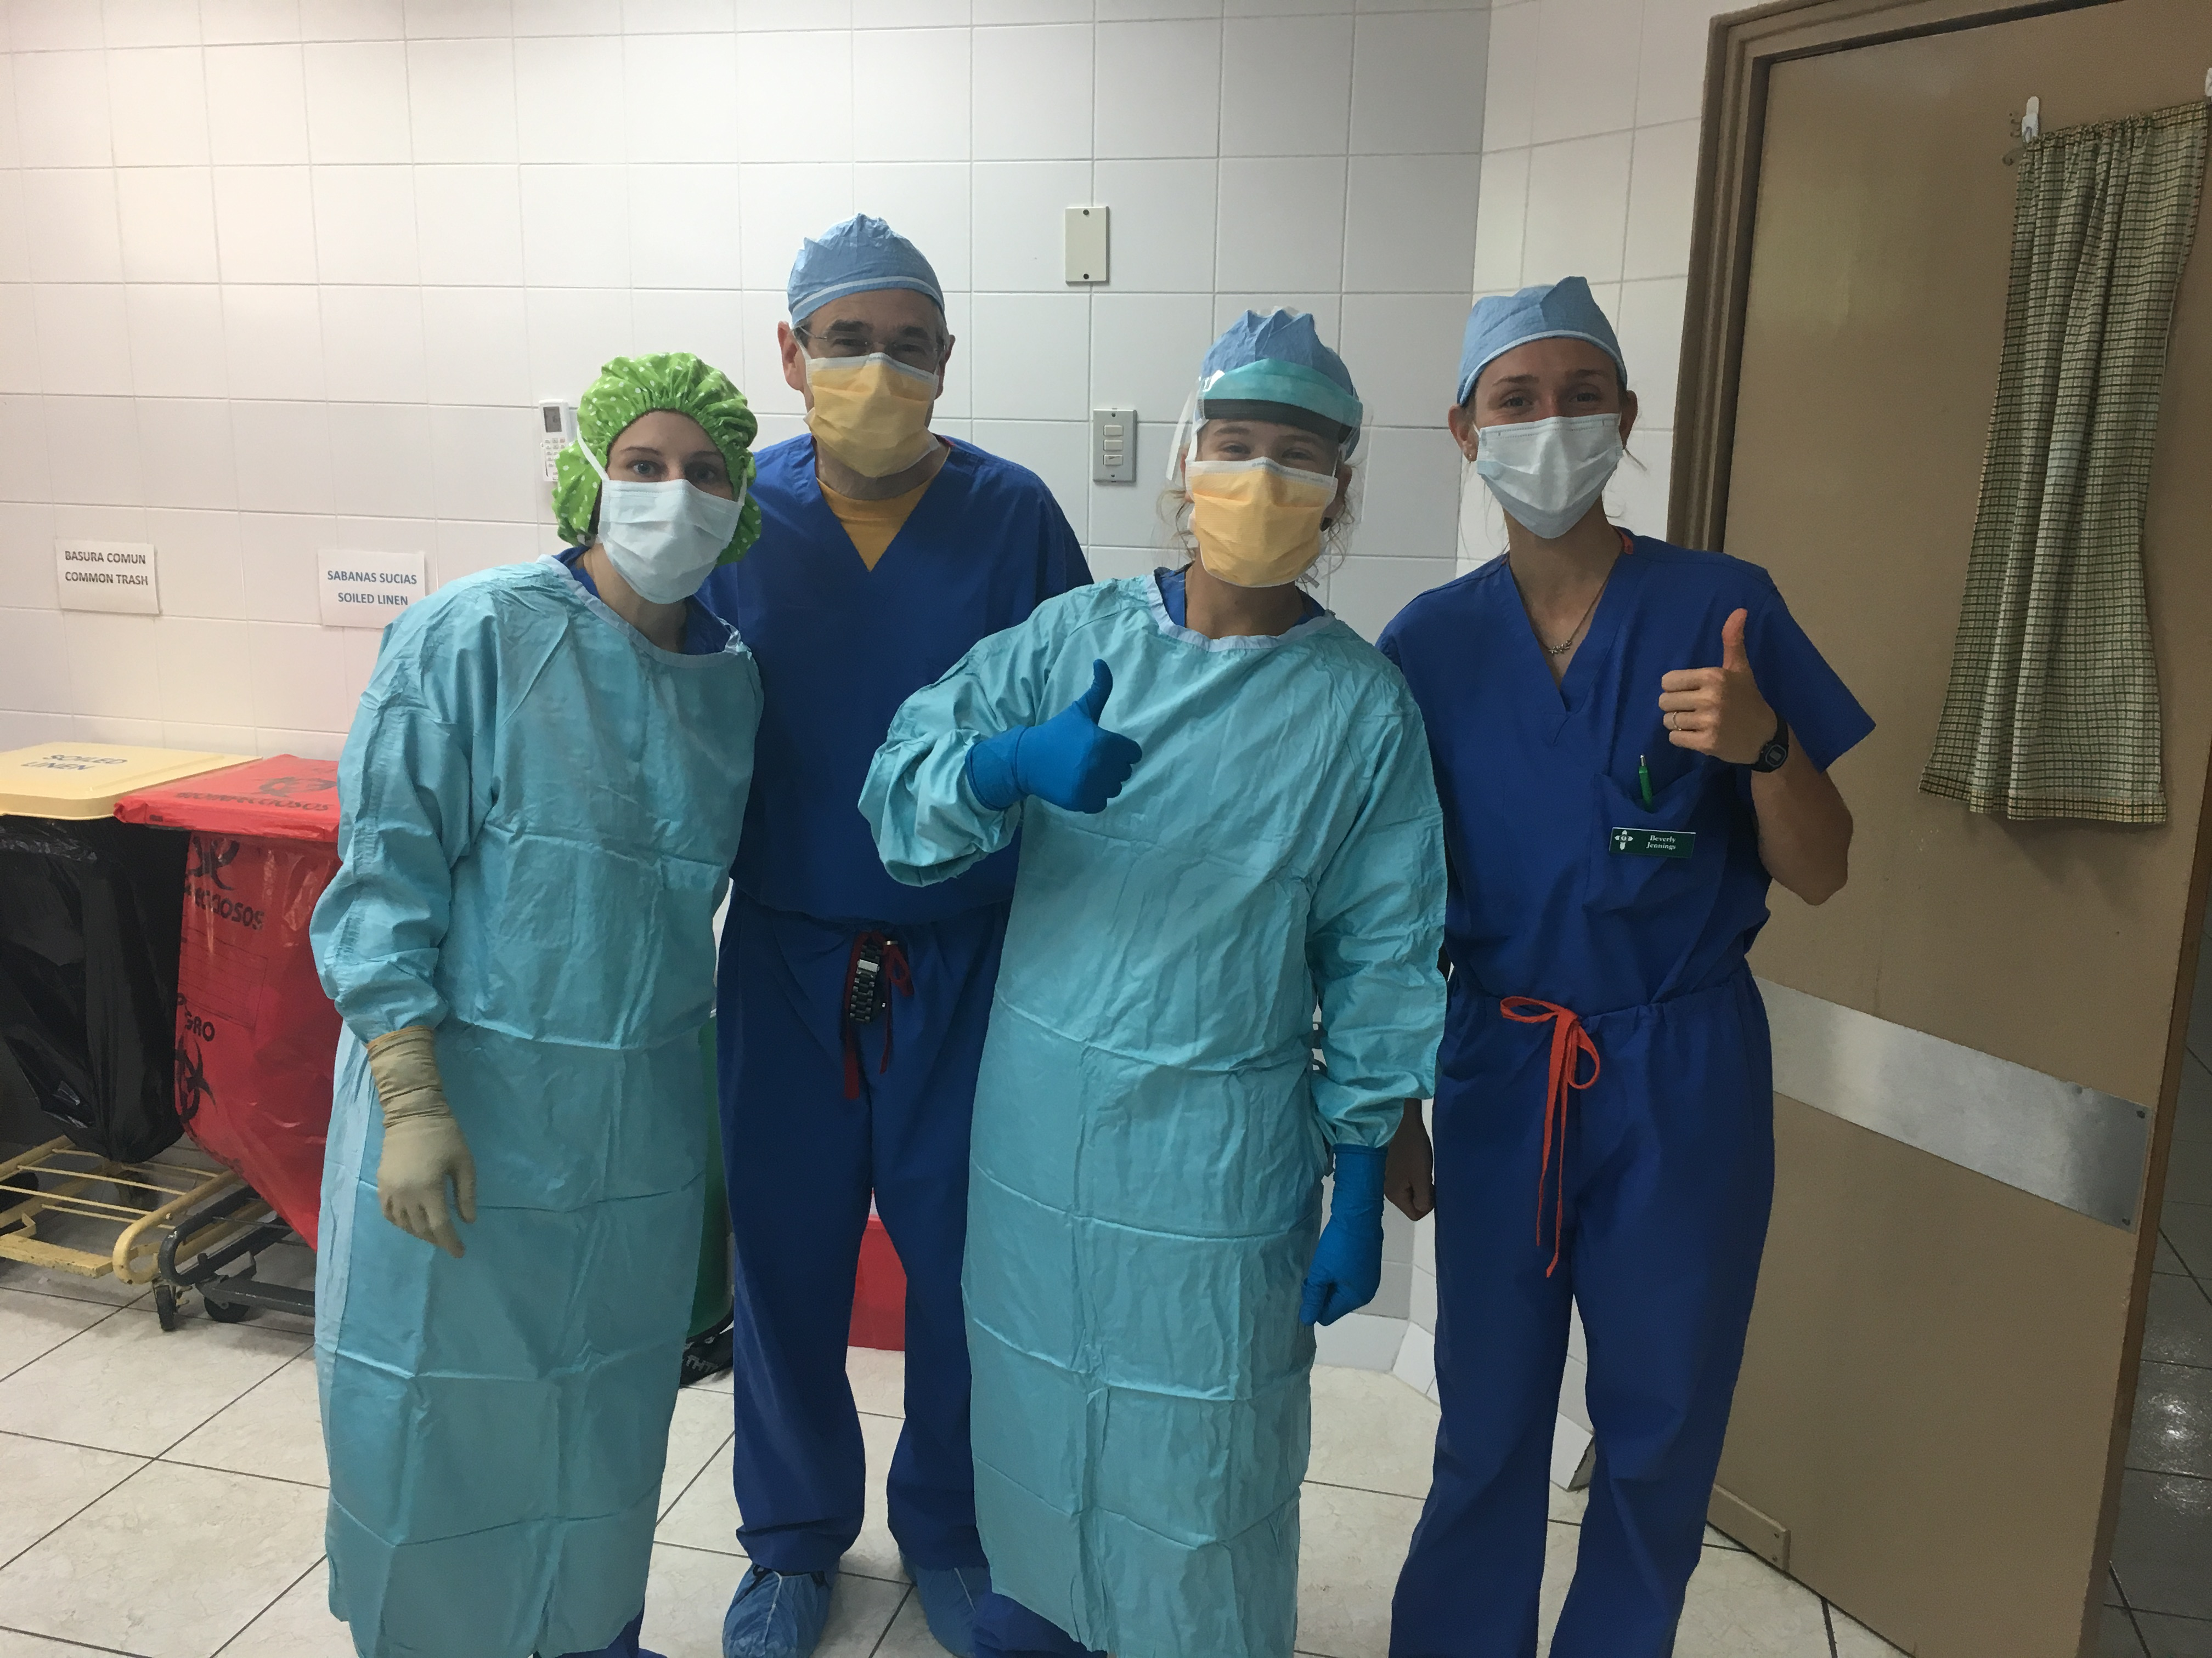The weather is hot and humid. Operating rooms are air conditioned and dormitory rooms are equipped with ceiling fans.
* Scrubs are provided. If you want to wear shorts in the dorm area that is fine, however wearing shorts to clinic is not appropriate for either sex.
* You will be on your feet all day. Closed toe shoes should be worn in surgical rooms. Shower shoes are helpful.
* A self-serve washer and dryer is available at Clinica Ezell.
* Towels and linens are provided.
* The only “street clothes” you will need are for Friday in Antigua and Saturday on your way home.
* Antigua is a higher altitude and can be chilly at night.
* You may want a nice outfit for dinner Friday evening if you are staying in Antigua.
* Your trip fee buys you an HTI t-shirt. Additional t-shirts may be purchased for $10 each.
* Leave your expensive jewelry at home.
* Bring personal medication in your carry on.
* Bring motion sickness medicine if you need it for the bus rides.
* Personal shampoo, soap, toothpaste, toothbrush, etc.
* Regular 110-volt outlets are available in your room and bathroom.

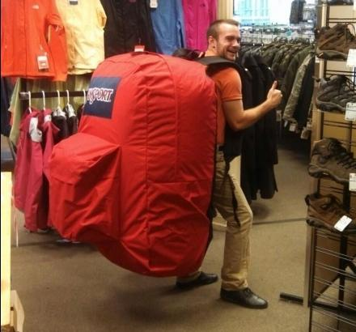**PACKING TIP:**  **Carryon bags are free (provided they fit in the overhead bin). Beyond that you will be charged for any checked bag. You are responsible for any charges if you choose to check a bag. If you check a bag, it cannot weigh more than 50 lbs., or you will be charged an overweight fee by the airline.**

**TRAVEL SAFETY**

In recent years, there has been an increasing level of crime in Guatemala, largely centered in and around Guatemala City. HTI is continually monitoring the situation and adjusting as needed for the safety of our teams. Team members will be given further instructions to ensure personal safety in Houston upon arrival in Guatemala. Our campus is gated, secure and guarded 24 hours a day. We are loved and respected by the local citizens.

**Disclaimer:** Guatemala is a developing country and can experience instability. HTI will take reasonable steps to ensure the personal safety of team members, but there are risks inherent in traveling, and working in such situations. Each team member assumes a certain amount of risk when he commits to participate in medical evangelism. Health Talents has sponsored medical evangelism trips for many years and has had very few problems. We want your trip to be a positive life-changing experience, so we request that you comply with our safety communications. For further information, consult the U.S. State Department Country Specific for Guatemala here: <http://travel.state.gov/content/passports/en/country/guatemala.html>

Each team member should take a moment to register with the American Embassy before traveling to Guatemala. This registration will help you immensely should you run into any issues while with us in Guatemala, like losing your passport. It only takes a few minutes. <https://step.state.gov/step/>

**CUSTOM FORMS ON THE PLANE - YOU’LL WANT TO KNOW THIS:**

Shortly before landing in Guatemala, the flight attendants will pass out customs forms. You will need a pen and your passport information to complete the form. There are a few questions you will find confusing, so here are the answers: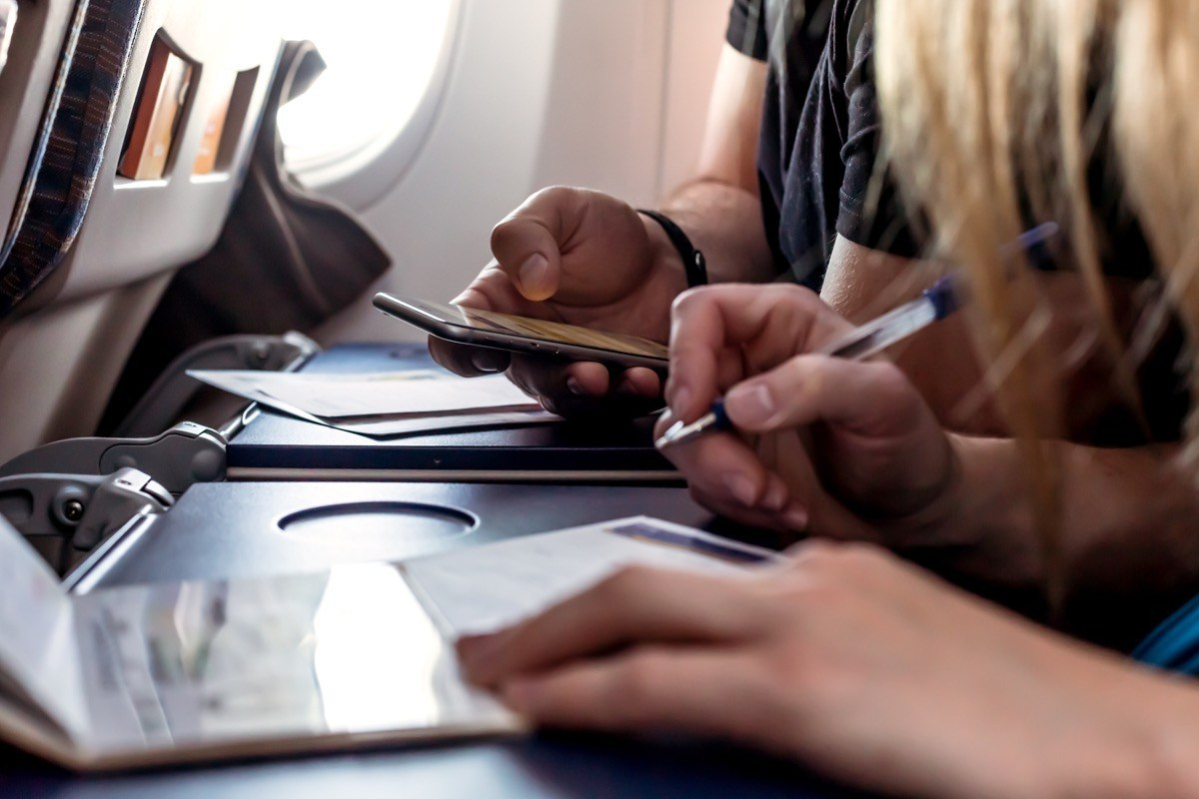

Question 9 – Write in: Clinica Ezell, Montellano, Suchi

Question 12 – Check Tourism and Other. (The “other” is medical missions if asked.)

Question 15 – Check NO (you are not carrying over $10,000 with you)

Question 17 – If you are bringing meds for HTI only check YES on the Drugs line. In most cases, the value of medicines you are bringing is less than $200. You may confidently use that amount unless otherwise informed. If you are not bringing medical supplies or medicine for HTI, check NO in all boxes in this section

Sign it - you are done! Now you can help those around you who do not know the answers :) They will take this form from you when you go through customs in the airport, so keep it handy.

**FAQS:**

**Q: *CAN I BRING OTC MEDS TO DONATE*?**

# *A: YES AND NO.* We appreciate any help you can provide in gathering donated medicines or supplies for the clinic, just be aware that we need an inventory list of these items 45 days prior to our departure. We must have approval from the Ministry of Health in Guatemala so there will not be any problems getting through customs. So, Yes! we want them, but only if we have time to get them approved. Click the link to see the items we use: ( LINK: OTC Meds to bring to Guatemala)

***Q: CAN I BRING CLOTHES AND SHOES TO GIVE AWAY?***

***A: NO.*** We have been working in Guatemala since 1978, and we have learned that such donations do not help the work of HTI or the churches. In fact, they have an adverse effect.  They cause chaos, jealousy and strife among the people and create a system of “beggars” overall. We have all seen here at home what harm welfare can do to an individual's motivation and expectations.  It is critical for us to avoid that in Guatemala if we have any hope of raising up a generation of people who genuinely believe that their hope is in the Lord Jesus. (LINK: Clothing Policy)

**Q:** ***SHOULD I KNOW ANY SPANISH WORDS OR PHRASES?***

***A: IT WOULDN’T HURT.*** Many people download a Spanish translator to their phone. (Be sure it does not require Wi-Fi to work) There will be several translators on our team, so you will not be responsible for learning Spanish! Here is a link to some helpful works and phrases: (insert LINK to Spanish words)

**Q:**  ***HOW DO I CALL HOME?***

***A:*** When calling on a cell phone in Guatemala the **country access code 001** for the USA must be dialed before the area code and number. Arrange for an out of country calling plan with your carrier before you leave or use one of the phones your team leaders keep for this purpose (free).

Example: 001-501-278-9415 to call Rick Harper in the USA from Guatemala.

When calling from the USA to Guatemala (GUA) you need to dial the international access code 011, country area code 502 and the number.

Example: 011-502-4011-8889 to call Rick in Guatemala from the USA.

***Q: HOW WILL I CHECK MY EMAIL?***

***A:*** We do not have open Wi-Fi for your smartphones and devices, so we will have laptops set up in the common area for your use.

**IMPORTANT CONTACT INFORMATION:**

Rick Harper: USA (501)278-9415; GUA (502)4011-8889; [HTIRick@aol.com](mailto:HTIRick@aol.com)

Bode Teague: USA (501)593-3581; bodeteague@gmail.com

Sheri Kretzschmar: USA (828) 201-9739; GUA (502) 4575-5074; fscubarn@aol.com

Dave Mellor: USA (423)4135415; [mellors@bellsouth.net](mailto:BrotherDave@outlook.com)

Susan Mellor: USA (423)580-7140; [mellors@bellsouth.net](mailto:Mellors@bellsouth.net)

Kemmel Dunham: GUA (502)57842044; [tsidirector@aol.com](mailto:tsidirector@aol.com)

**Additional & Important Information:**

CDC Immunization Information

License Requirements (Professional Documentation)

Tips from Veterans

Zika Recommendations